Implementation Assignment #2: Docker and containers
1. Describe the environment you used and programming language.
2. Describe the Docker containers you developed and Docker files.
3. Describe how you ran your containers and the results you got.
4. Instructions on how to build and run the application with the port number used.
5. Reflection on testing, observations, challenges, etc.
6. References as applicable for any resources you used.

Introduction (#1-4)
The environment that I used was Java 15+ with the package manager being Apache Maven. Using Docker, I created a compose.yml file that detailed the dependency order of the project. Alongside this I created Dockerfile.client and Dockerfile.server to have a custom startup with the client and server images respectively. With this after using docker compose up --build server command and the docker compose up --build --scale client=10 client, I was able to deploy this simple server and client server.
The server successfully built in Java and hard-coded exposed port 8080 for the clients to connect.
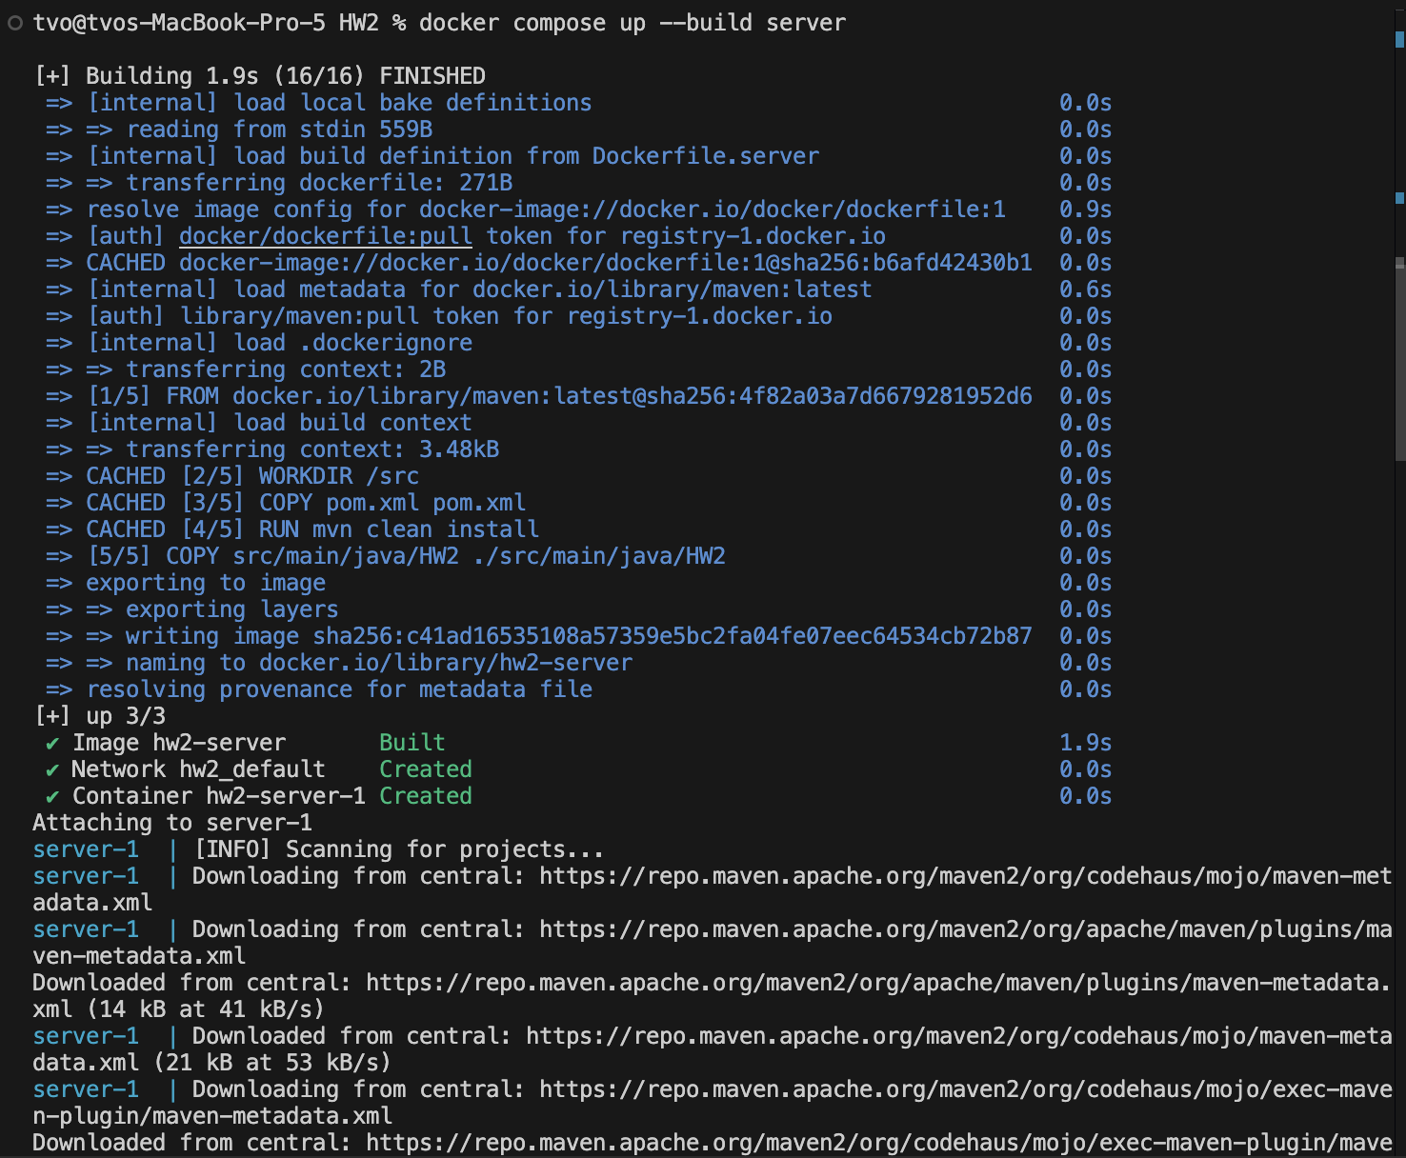
The client successfully built in Java to connect to the exposed port 8080.
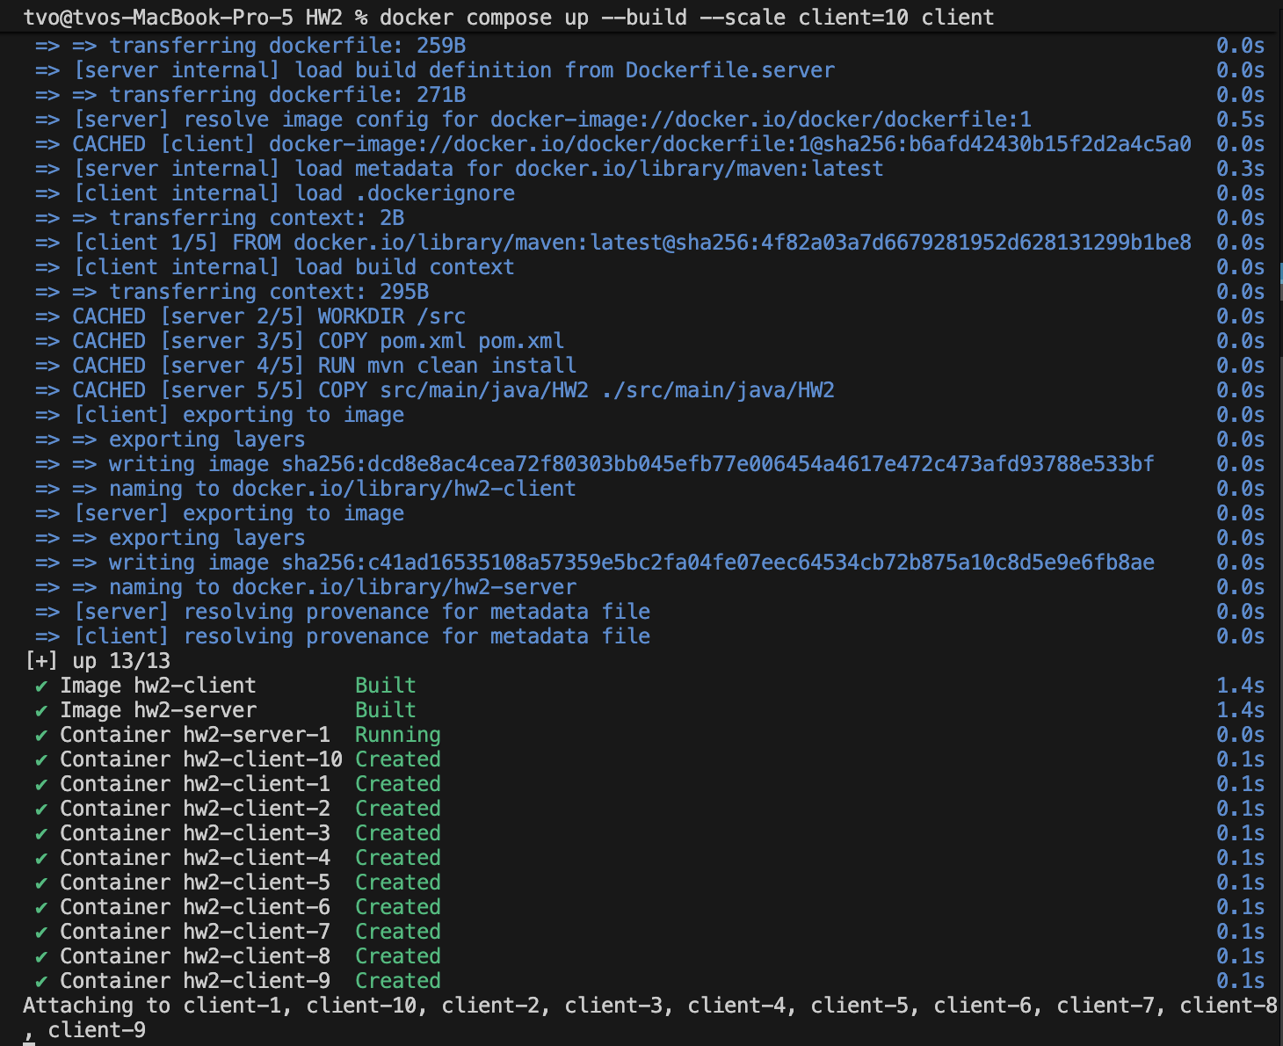

Reflection of Testing, Observations and Challenges
Testing was done before the deployment of the Server and Client. I used Apache Maven to test the Client and Server Application by mocking the expected output with the modified input or function call using the Java Library Mocktio. Using mvn clean test, you can run the tests created for the Client and server. Mocking the client needed to be updated since there should be a flag to notate sleeping messages or not from the previous assignment.
From my observations, the docker containers seems to be installing the same packages to the client images. This is interesting since I each image should be the same, but why is it that they are having duplicated installs without copying from another image to another.
One of the biggest challenges of this project was learning the coordination of the docker containers, before I notated the dependencies in the yaml file. I would run the client first, but I would get errors, since the server’s Ip address was not available yet.
Testing
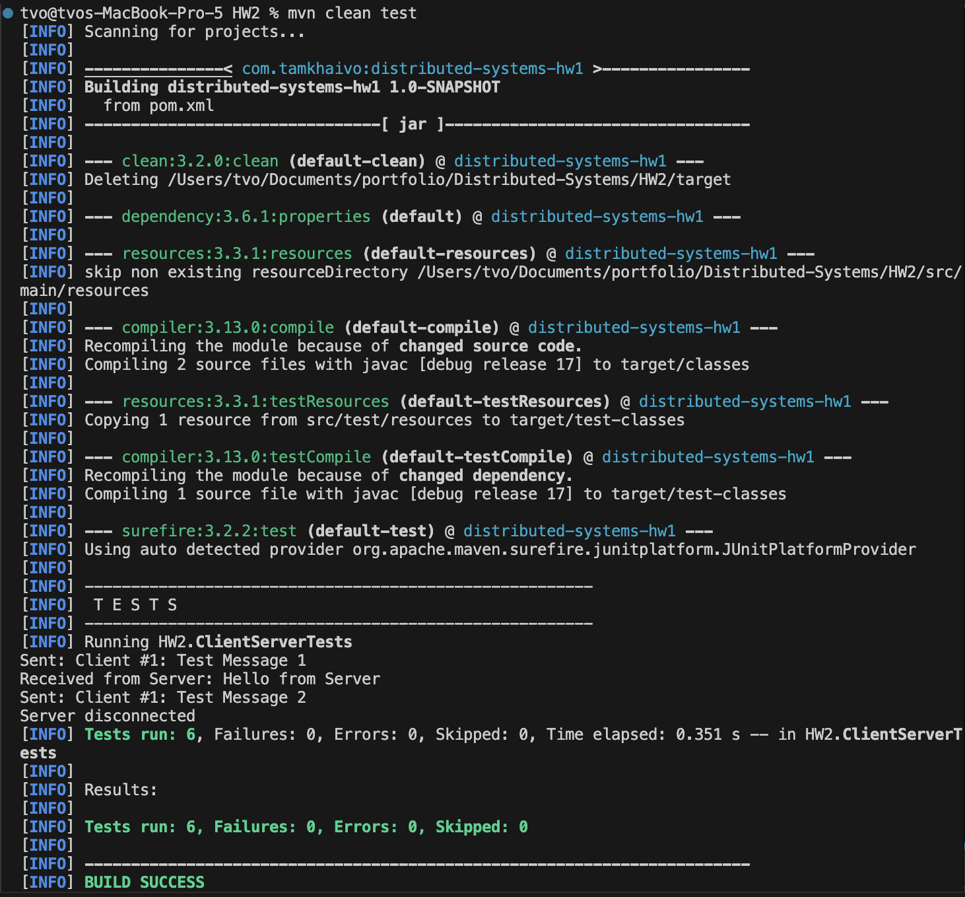

References
- https://site.mockito.org
- https://www.w3schools.com/java/java_threads.asp
- https://docs.docker.com/compose/
- https://www.geeksforgeeks.org/java/socket-programming-in-java/

